# B.1. Three-bar truss design problem.

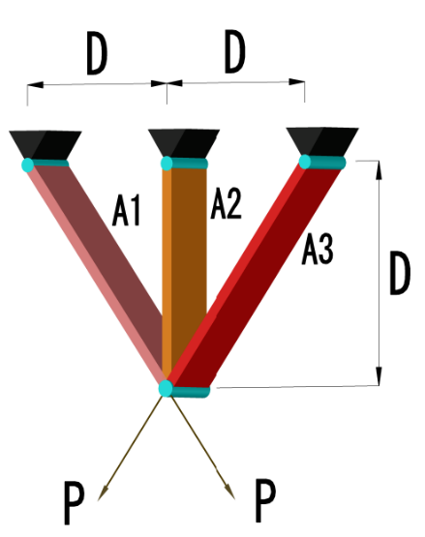

$$minf(x)=\left(2\sqrt{2}x_{1}+x_{2}\right)×l$$

|  |  |
| --- | --- |
| Subject to: | $$0≤x_{i}≤1, i=1,2$$ |
|  | $$l=100 cm, P=2kN/{cm}^{2}, σ=2kN/{cm}^{2}$$ |
|  | $$g_{1}(x)=\frac{\sqrt{2}x_{1}+x_{2}}{\sqrt{2}x_{1}^{2}+2x_{1}x_{2}}P-σ≤0$$ |
|  | $$g_{2}(x)=\frac{x_{2}}{\sqrt{2}x_{1}^{2}+2x_{1}x_{2}}P-σ≤0$$ |
|  | $$g_{3}(x)=\frac{1}{\sqrt{2}x_{2}+x_{1}}P-σ≤0$$ |

# B.2. Pressure vessel design problem.

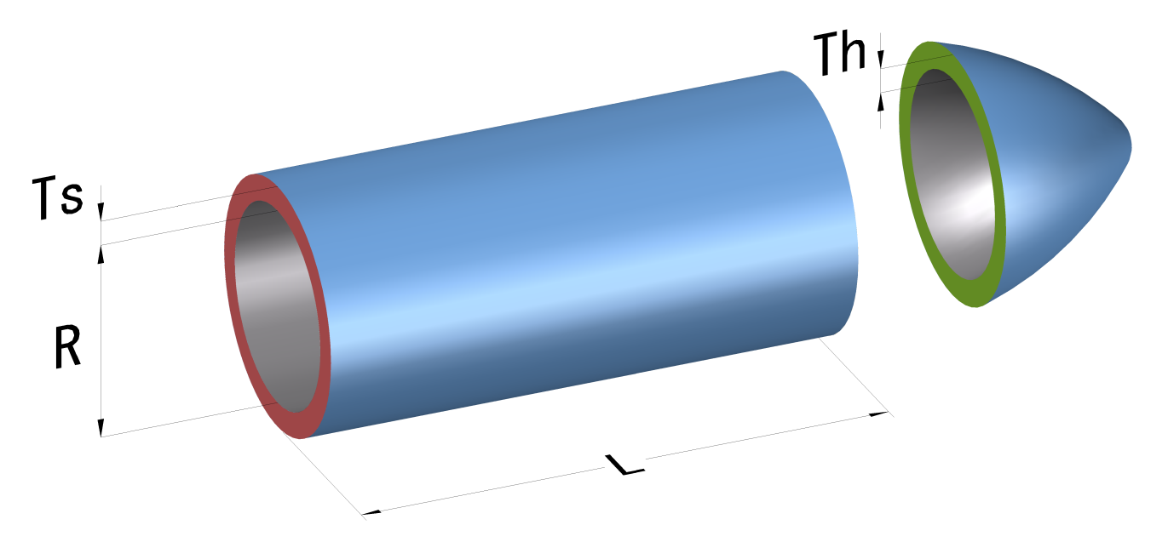

$$minf(x)=0.6224x_{1}x_{3}x_{4}+1.7781x_{2}x_{3}^{2}+3.1661x_{1}^{2}x_{4}+19.84x_{1}^{2}x_{3}$$

|  |  |
| --- | --- |
| Subject to: | $$0≤x_{i}≤100, i=1,2$$ |
|  | $$10≤x_{i}≤200, i=3,4$$ |
|  | $$g_{1}(x)=-x_{1}+0.0193x$$ |
|  | $$g_{2}(x)=-x_{2}+0.00954x_{3}≤0$$ |
|  | $$g_{3}(x)=-πx_{3}^{2}x_{4}-(4/3)πx_{3}^{3}+1,296,000≤0$$ |
|  | $$g_{4}(x)=x_{4}-240≤0$$ |

# B.3. Tension/compression spring design problem.

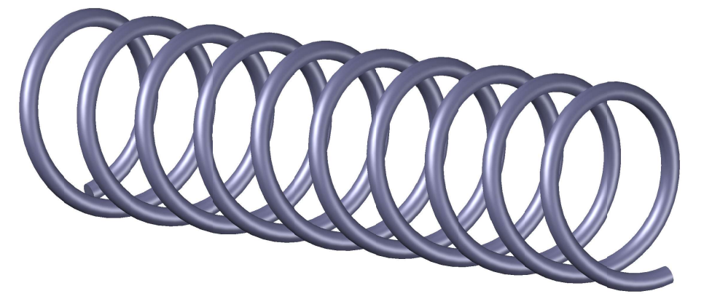

$$f(x)=\left(x_{3}+2\right)x_{2}x_{1}^{2}$$

|  |  |
| --- | --- |
| Subject to: | $$0.05≤x_{1}≤2.00$$ |
|  | $$0.25≤x_{2}≤1.30$$ |
|  | $$2.00≤x_{3}≤15.00$$ |
|  | $$g_{1}(x)=1-\left(x_{2}^{3}x_{3}/71,785x_{1}^{4}\right)≤0$$ |
|  | $$g_{2}\left(x\right)=\left(4x_{2}^{2}-\frac{x_{1}x_{2}}{12,566\left(x_{2}x_{1}^{3}-x_{1}^{4}\right)}\right)+\left(\frac{1}{5108x_{1}^{2}}\right)-1≤0$$ |
|  | $$g_{3}(x)=1-\left(140.45x_{1}/x_{2}^{2}x_{3}\right)≤0$$ |
|  | $$g_{4}(x)=\left(x_{2}+x_{1}\right)/1.5-1≤0$$ |

# B.4. Welded beam design problem.

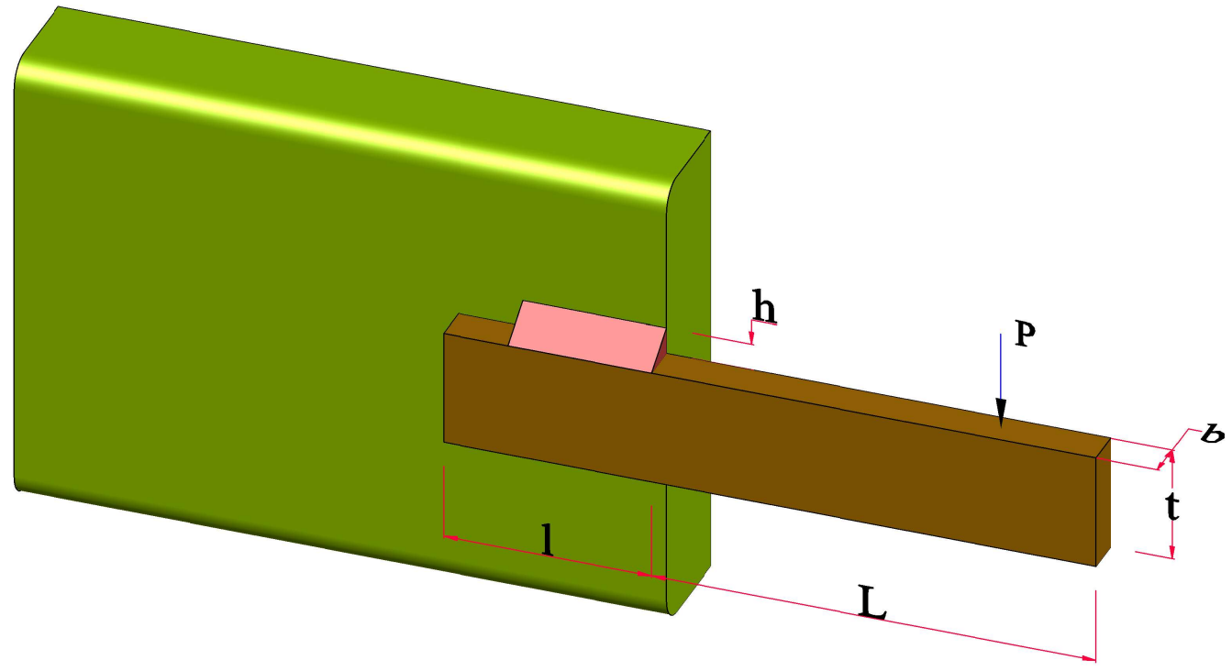

$$f(x)=1.10471x_{1}^{2}x_{2}+0.04811x_{3}x_{4}\left(14+x_{2}\right)$$

|  |  |
| --- | --- |
| Subject to: | $$0.1≤x_{i}≤2, i=1,4$$ |
|  | $$0.1≤x_{i}≤10, i=2,3$$ |
|  | $$g_{1}(x)=τ(x)-τ_{max}≤0$$ |
|  | $$g_{2}(x)=σ(x)-σ_{max}≤0$$ |
|  | $$g_{3}(x)=x_{1}-x_{4}≤0$$ |
|  | $$g_{4}(x)=0.10471x_{1}^{2}+0.04811x_{3}x_{4}\left(14+x_{2}\right)-5≤0$$ |
|  | $$g_{5}(x)=0.125-x_{1}≤0$$ |
|  | $$g_{6}(x)=δ(x)-δ_{max}≤0$$ |
|  | $$g_{7}(x)=P-P_{c}(x)≤0$$ |
| Where: | $$τ(x)=\sqrt{{\left(τ^{'}\right)}^{2}+2τ^{'}τ^{''}\frac{x_{2}}{2R}+{\left(τ^{''}\right)}^{2}}$$ |
|  | $$τ^{'}=\frac{P}{\sqrt{2}x_{1}x_{2}}, τ^{''}=\frac{MR}{J}$$ |
|  | $$M=P\left(L+\frac{x_{2}}{2}\right), R=\sqrt{\frac{x_{2}^{2}}{4}+{\left(\frac{x_{1}+x_{3}}{2}\right)}^{2}}$$ |
|  | $$J=2\left\{\sqrt{2}x_{1}x_{2}\left[\frac{x_{2}^{2}}{12}+{\left(\frac{x_{1}+x_{3}}{2}\right)}^{2}\right]\right\}$$ |
|  | $$σ(x)=\frac{6PL}{x_{4}x_{3}^{2}}, δ(x)=\frac{4PL^{3}}{Ex_{3}^{3}x_{4}}$$ |
|  | $$P_{c}(x)=\frac{4.013E\sqrt{\left(x_{3}^{2}x_{4}^{6}/36\right)}}{L^{2}}×\left(1-\frac{x_{3}}{2L}\sqrt{\frac{E}{4G}}\right)$$ |
| $P=6000 (lb), L=14 (in), E=30×{10}^{6 }(psi), G=12×{10}^{6}$ (psi) | |
| $τ_{max}=13,600 \left(psi\right), σ_{max}=30,000 (psi), δ_{max}=0.25$ (in) | |

# B5. Cantilever beam.

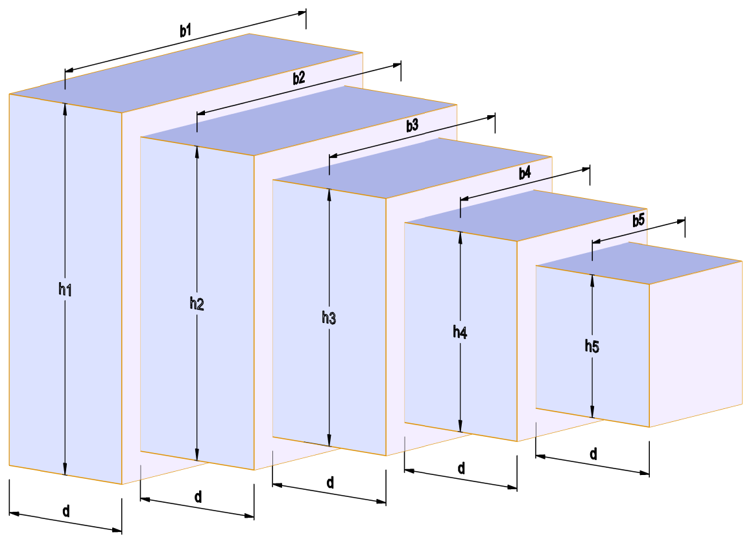

Minimize the beam volume,

$$f(x)=l\left(x_{1}x_{2}+x_{3}x_{4}+x_{5}x_{6}+x_{7}x_{8}+x_{9}x_{10}\right)$$

Five nonlinear bending stress constraints,

$$\begin{matrix} & g_{1}=\frac{6Pl}{x_{9}x_{10}^{2}}-σ_{max}≤0;g_{2}=\frac{6P(2l)}{x_{7}x_{8}^{2}}-σ_{max}≤0 \\ & g_{3}=\frac{6P(3l)}{x_{5}x_{6}^{2}}-σ_{max}≤0;g_{4}=\frac{6P(4l)}{x_{3}x_{4}^{2}}-σ_{max}≤0 \\ & g_{5}=\frac{6P(5l)}{x_{1}x_{2}^{2}}-σ_{max}≤0\end{matrix}$$

One stiffness constraint,

Table 1  
Design variables and its ranges [2].

|  |  |
| --- | --- |
| Design variables | Range $(cm)$. |
| $$x_{1}$$ | $$1-5$$ |
| $$x_{2}$$ | $$30-65$$ |
| $$x_{3},x_{5}$$ | $$2.4-3.1$$ |
| $$x_{4},x_{6}$$ | $$45-60$$ |
| $$x_{7},x_{9}$$ | $$1-5$$ |
| $$x_{8},x_{10}$$ | $$30-65$$ |

Table 2  
Constant parameters and its values [2].

|  |  |
| --- | --- |
| Other parameters | Value |
| The total beam length, $L( cm)$ | 500 |
| Length of the individual section, $l( cm)$ | 100 |
| Load, $P(N)$ | 50,000 |
| Maximum deflection of beam, $δ_{max}(cm)$ | 2.7 |
| Allowable stress in each section, $σ_{max}\left(N/{cm}^{2}\right)$ | 14,000 |
| Young's modulus, $E\left(N/{cm}^{2}\right)$ | $$2×{10}^{7}$$ |

$$g_{6}=\frac{Pl^{3}}{E}\left(\frac{244}{x_{1}x_{2}^{3}}+\frac{148}{x_{3}x_{4} ^{3}}+\frac{76}{x_{5}x_{6} ^{3}}+\frac{28}{x_{7}x_{8}^{3}}+\frac{4}{x_{9}x_{{10}^{3}}}\right)-δ_{max}≤0$$

A constant ratio of twenty is maintained between the height and width of beam cross section [13].  
Five geometrical constraints,

|  |
| --- |
| $$g_{7}=\left(\frac{x_{2}}{x_{1}}\right)-20≤0;g_{8}=\left(\frac{x_{4}}{x_{3}}\right)-20≤0;g_{9}=\left(\frac{x_{6}}{x_{5}}\right)-20≤0;$$ |
| $$g_{8}=\left(\frac{x_{4}}{x_{3}}\right)-20≤0$$ |
| $$g_{9}=\left(\frac{x_{6}}{x_{5}}\right)-20≤0$$ |
| $$g_{10}=\left(\frac{x_{8}}{x_{7}}\right)-20≤0$$ |
| $$g_{11}=\left(\frac{x_{10}}{x_{9}}\right)-20≤0$$ |

# B.6 Disc Brake

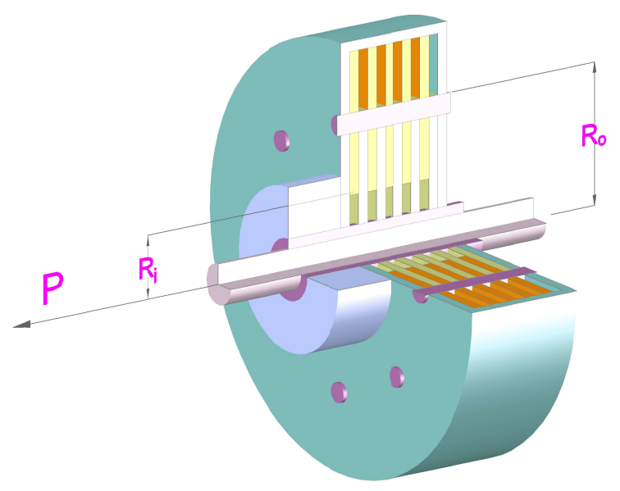

4.1. Multiobjective Disc Brake Optimization Problem. The multiobjective disc brake optimization problem was solved by Osyczka and Kundu [21] using plain stochastic method and genetic algorithms for optimization of disc brake problem. They have shown that genetic algorithm was giving better results compared with that of plain stochastic method. The objectives of the problem are to minimize the mass of the brake and to minimize the stopping time. The disc brake optimization model has four variables (as shown in Figure 2) that are  
(1) $R_{i}$, inner radius of the discs, in $mm=x_{1}$,  
(2) $R_{o}$, outer radius of the discs, in $mm=x_{2}$,  
(3) $F$, engaging force, in $N=x_{3}$,  
(4) $n$, number of the friction surfaces (integer) $=x_{4}$.  
The objective functions and constraints of the disc brake design optimization model provided by Osyczka and Kundu [21] are defined as follows.  
Objective Functions  
Mass of the brake:

|  |
| --- |
| $$f_{1}(x)=4.9×{10}^{-5}\left(x_{2}^{2}-x_{1}^{2}\right)\left(x_{4}-1\right), \text{in} kg.$$ |

Stopping time:

|  |
| --- |
| $$f_{2}(x)=\frac{9.82×{10}^{6}\left(x_{2}^{2}-x_{1}^{2}\right)}{x_{3}x_{4}\left(x_{2}^{3}-x_{1}^{3}\right)}, \text{in s.}$$ |

The constraints are as follows.

(1) Side constraints $55≤x_{1}≤80,75≤x_{2}≤110,1000≤$ $x_{3}≤3000,2≤x_{4}≤20$.  
(2) Geometric constraints  
(i) Minimum distance between radii:

|  |
| --- |
| $$g_{1}(x)=\left(x_{2}-x_{1}\right)-20≥0.$$ |

(ii) Maximum length of the brake:

|  |
| --- |
| $$g_{2}(x)=30-2.5\left(x_{4}+1\right)≥0.$$ |

(3) Behaviour constraints  
(i) Pressure constraint

|  |
| --- |
| $$g_{3}(x)=0.4-\frac{x_{3}}{3.14\left(x_{2}^{2}-x_{1}^{2}\right)}≥0\text{.}$$ |

(ii) Temperature constraint

|  |
| --- |
| $$g_{4}(x)=1-\frac{2.22×{10}^{-3}x_{3}\left(x_{2}^{3}-x_{1}^{3}\right)}{{\left(x_{2}^{2}-x_{1}^{2}\right)}^{2}}≥0.$$ |

(iii) Generated torque constraint

|  |
| --- |
| $$g_{5}(x)=\frac{2.66×{10}^{-2}x_{3}x_{4}\left(x_{2}^{3}-x_{1}^{3}\right)}{\left(x_{2}^{2}-x_{1}^{2}\right)}-900≥0.$$ |